How to Create a New Job Template and Run a Job
Log in to ondemand3.osc.edu

From the Dashboard, select Jobs > My Jobs
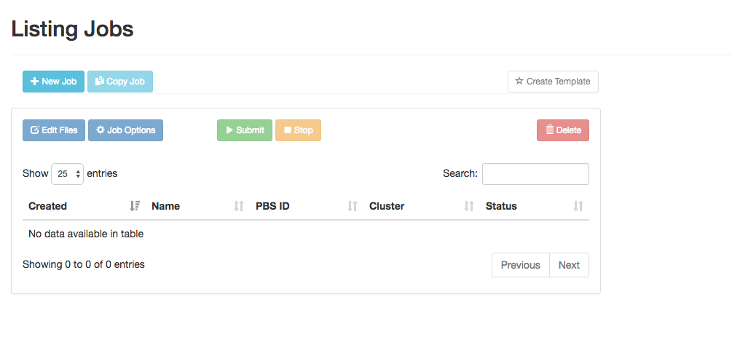
Select My Templates > Add a New Template
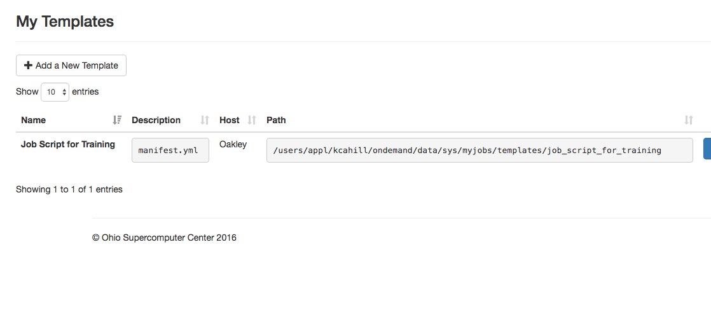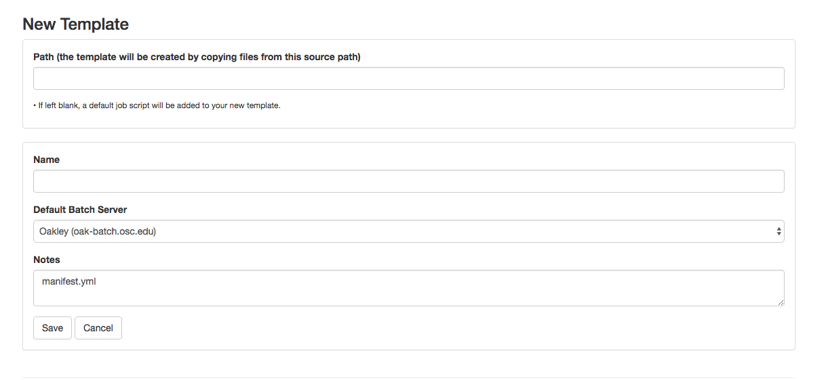
Enter the following the Path box:

/users/appl/kcahill/ondemand/data/sys/myjobs/templates/training

Name job workshop_job Save

Select My Jobs on the banner

Select New Job

Select workshop_job and Create New Job

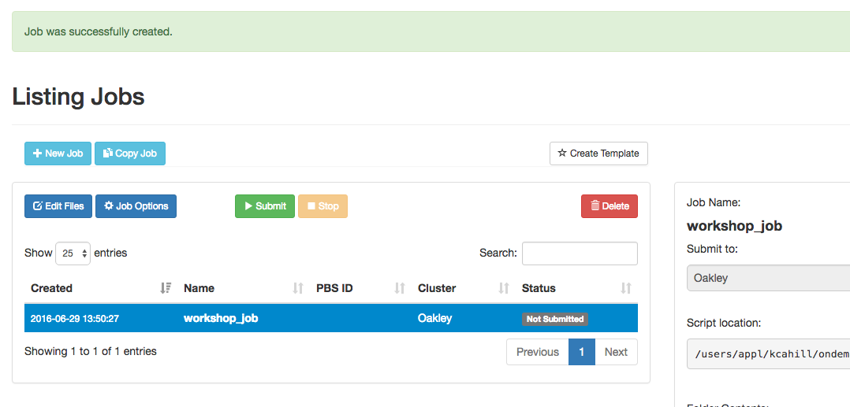

Select Edit Files

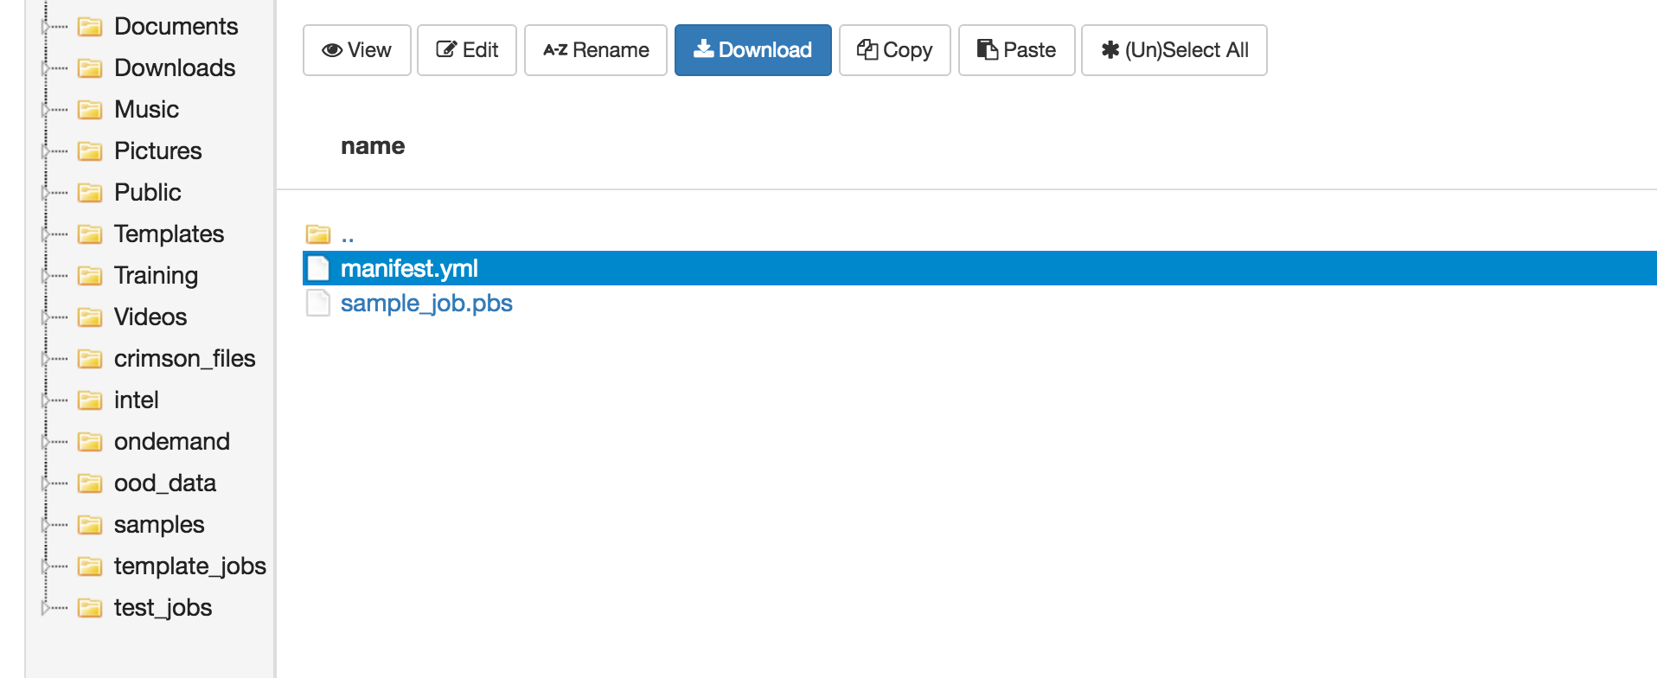
Select sample_job.pbs and Edit

Find line below:

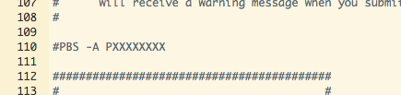

Change PXXXXXX to PZS0557

Save and close editor; close File explorer; Select Submit to Run job

